BEDFORDSHIRE

SMALL-BORE

SHOOTING

ASSOCIATION

Air Gun Section

Data Protection Act 1984: The Competition Organiser is required to inform that the following will be stored on computer for the purposes of preparing entry forms and other internal purposes:
Name, Address,Telephone and other Shooting connected information. This information will be for the use of County Officials only.
If you do not wish your details to be kept on computer or if you wish to view your computer records, please make contact with the Competition organiser.

BEDFORDSHIRE SMALLBORE
SHOOTING ASSOCIATION

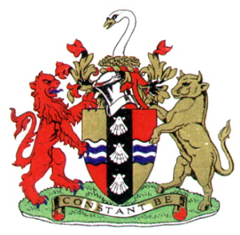

BEDFORDSHIRE OPEN

AIR GUN MEETING

AT
BEDFORD RANGES, CLAPHAM ROAD, BEDFORD,
MK41 6EN

Saturday 23rd and Sunday 24th January 2016

BEDFORDSHIRE SMALL-BORE SHOOTING
ASSOCIATION

AIR GUN COMPETITION

THE MEETING IS SHOT OVER 10 METRES

THE COURSE OF FIRE IS 60 SHOTS

ISSF RULES WILL BE OBSERVED

TARGET CHANGERS ARE IN USE

Please Note
Details 4 and 8 will only be available if all other details are full
Firing points will be allocated on a 1st come 1st served basis
Pistol trigger weights will be tested

PLEASE RETURN ENTRY FORMS TO:-

Steve Finnie
17 Weatherby, Dunstable
Beds, LU6 1TP
Tel - 01582 534329

PLEASE MAKE CHEQUES PAYABLE TO:- BEDS.S.S.A.

Please tick one of the options below

Receive Squad Details and Results by e-mail
Receive Squad Details and Results by Post. (Please include 2 SAE with your entry)

ENTRY FORM

Name
Address
County |  | Club
Post Code |  | Phone No.
E-mail
Signature

Comp |  |  | Avg. ext100 | Fee
1 | 10 Metre | Rifle |  | £10.00
2 | 10 Metre | Pistol |  | £10.00

Please Indicate a First and Second Choice
Sat 23rd Jan | Det 1  10.00 | Det 2  12.00 | Det 3  2.00 | Det 4  4.00
Sun 24th Jan | Det 5  9.30 | Det 6  11.30 | Det 7  1.30 | Det 8  3.30

